Salt Dough & spring figures
- VOCABULARIO
- Flour | - Star | - Bowl
- Water | - Moon | - Dry
- Dough | - Oil | - Messy
- Snail | - Stir up | - Clean
- MATERIALES
  - Harina (Flour)
  - Agua (Water)
  - Sal (Salt)
  - Aceite de oliva o aromático (Olive oil or aromatics oils)

A pirate day
- VOCABULARIO
- Map | - Patch | - Ship
- Coffee | - Hunt | - Yarn
- Pirate | - Hook | - Facepaint (make up)
- Treasure | - Beard | - Wooden sticks

- MATERIALES
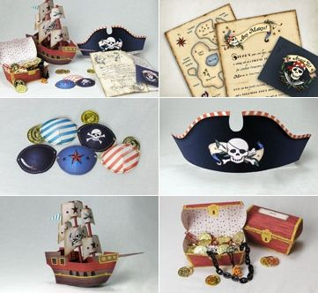
  - Papeles (Papers)
  - Poso de café (Coffee grounds)
  - Cartulina (Cardboard)
  - Brick de leche (Brick)
  - Palitos de helado (wooden sticks)
  - Rotuladores (Pens)

